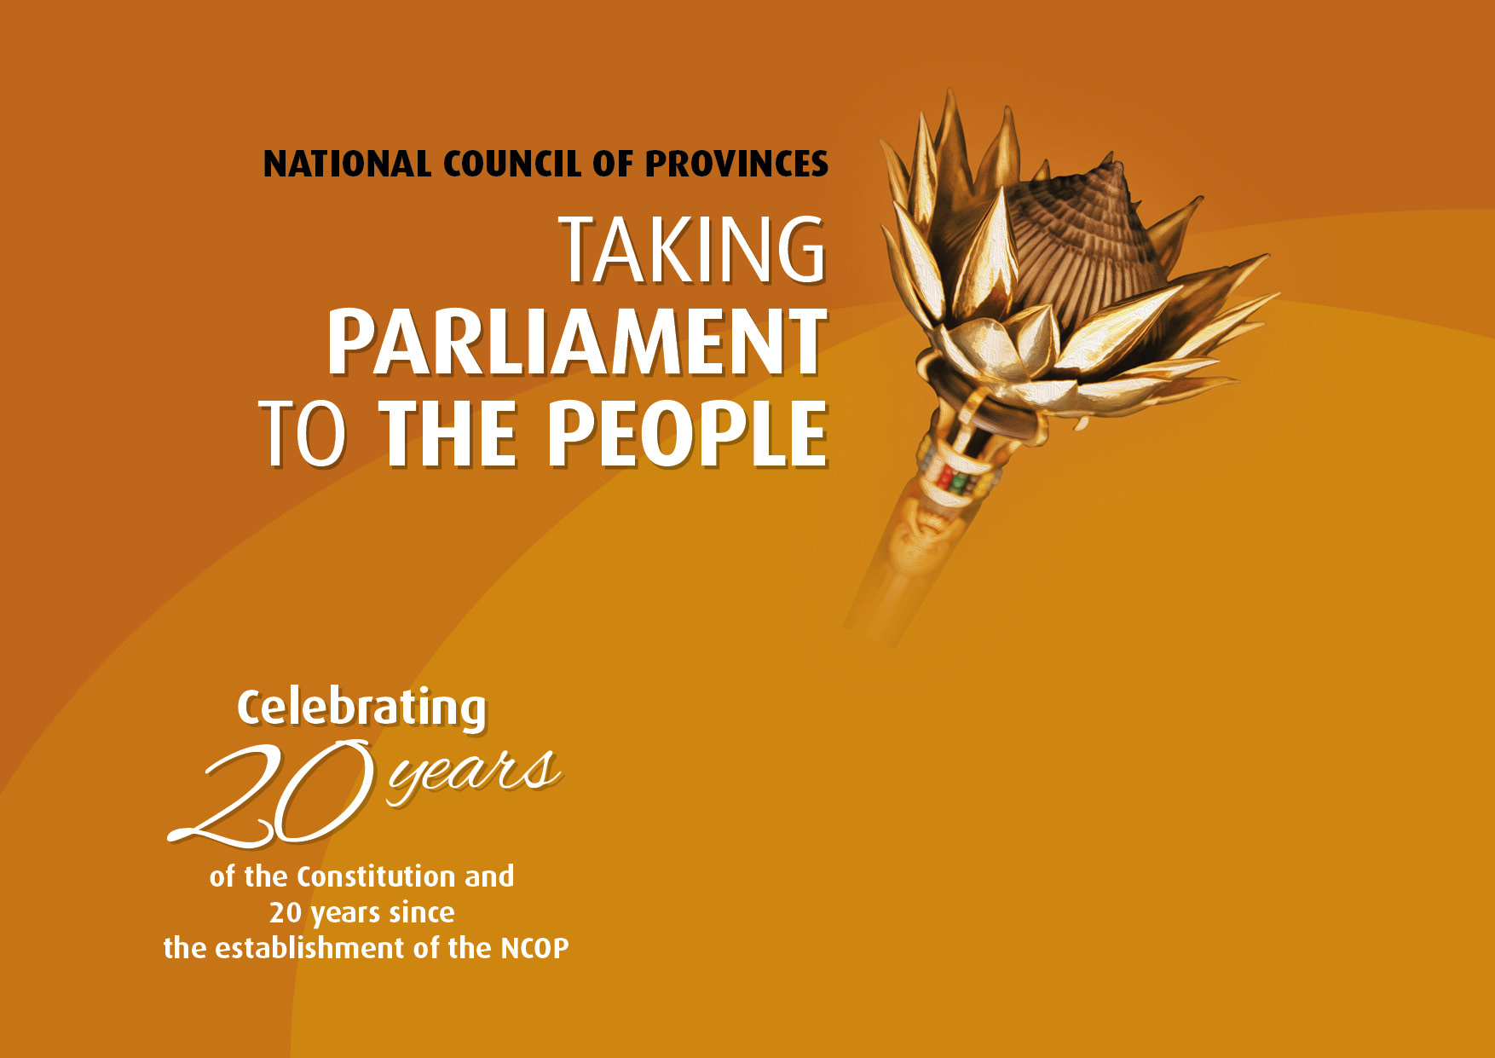
Programme
Main visit: Mangaung Metropolitan Municipality, Free State Province
Dates: 21 – 25 August 2017
Theme:Celebrating 20 years of the Constitution and 20 years since the establishment of the NCOP- Deepening Parliamentary Oversight for quality services to our people
Venue: Kaiser Sebothelo Sports Arena, Botshabelo
Enquiries: Jeremy Michaels
Tel: 021 403 3245
E-mail: jmichaels@parliament.gov.za

DAY 4 | TIME | ACTIVITY
Thursday,  24 August 2017 | 08h00 | Transport leaves to Kaiser Sebothelo Sports Arena, Botshabelo
Thursday,  24 August 2017 | 09h00 – 13h00 | PUBLIC HEARING ON LOCAL GOVERNMENT, PUBLIC WORKS, FINANCE AND EDUCATION  Programme Directors:  Hon. T R Modise – Chairperson of the NCOP  Hon. A J Nyambi – House Chairperson: Committees and Oversight  Theme: Provision of basic services  - Inputs and questions by members of the public  - Responses by Ministers, Provincial Ministers, Mayors and other panellists  Panellists:  Hon. D D Van Rooyen, Minister of Co-operative Governance and Traditional Affairs  Hon. N P Mokonyana, Minister of Water and Sanitation  Hon. S H Ntombela, MEC for Co-operative Governance, Traditional Affair and Human Settlements  Cllr.S M Mlamleli, Executive Mayor of Mangaung Metropolitan Municipality  Hon. M Mohapi, Chairperson of the Select Committee on Co-operative Governance and Traditional Affairs  Hon. M Mokotla, Chairperson of the Portfolio Committee on Co-operative Governance, Office of the Premier, Legislature and Police  Cllr. M A Morake, MMC: Human Settlement
Thursday,  24 August 2017 | 13h00 – 14h00 | - LUNCH BREAK

DAY 4  (cont...) | TIME | ACTIVITY
Thursday,  24 August 2017 | 14h00 – 16h30 | PUBLIC HEARING ON LOCAL GOVERNMENT, PUBLIC WORKS, FINANCE AND EDUCATION  Programme Directors:  Hon. C J De Beer – Chairperson of the Select Committee on Finance  Hon. S Moleleki – Chairperson of the Portfolio Committee on Public Works, Infrastructure, Roads, Transport and Human Settlements  Theme: Finance and Infrastructure  - Inputs and questions by members of the public  - Responses by Ministers, Provincial Ministers, Mayors and other panellists  Panellists:  Hon.D D Van Rooyen, Minister of Co-operative Governance and Traditional Affairs  Hon. M K N Gigaba, Minister of Finance  Hon. S H Ntombela, MEC for Co-operative Governance, Traditional Affairsand Human Settlements  Cllr. S M Mlamleli, Executive Mayor of Mangaung Metropolitan Municipality  Cllr. L M Titi-Odili, MMC: Finance, IDP and Performance Management
Thursday,  24 August 2017 | 17h00 | - Transport leaves to hotels / lodges

DAY 5 | DUTY WHIPS/  CO-ORDINATORS | TIME | ACTIVITY
Friday,  25 August 2017 |  | 08h00 | - Transport leaves to Kaiser Sebothelo Sports Arena, Botshabelo
Friday,  25 August 2017 | Duty Whips:  Hon. M L Moshodi  Hon. T K Mampuru  Protocol  Co-ordinators:  Ms. Z Kroese  Logistics  Co-ordinator:  Ms. Z. Zondi  Ms. Y Daniels  Plenary  Co-ordinator:  Mr. B. Nonyane | 08h30  09h00 – ±13h00 | All delegates to be seated  PLENARY:  ORDER OF THE DAY:Address to the NCOP by the Deputy President of the RSA  Theme: Celebrating 20 Years of the Constitution & the NCOP - Deepening Parliamentary Oversight for quality services to our people
Friday,  25 August 2017 |  | 13h00 – 14h00 | - LUNCH BREAK  - DEPARTURE TO CONSTITUENCIES

